ENPM680 Final Project: Phase 1
RetroBytes - A Place for Retro and
Vintage Items

By
Name | Sai Praneeth Koti
Email | ksp@umd.edu
Directory ID | ksp
UID | 121297495

Table of Contents
1. Application Description 3
a. Overview 3
b. Scope 3
c. Functionalities 3
2. Use Cases 4
Use Case #1: Browse Catalog by Category 4
Use Case #2: Check Local Stock Availability 5
Use Case #3: Add Item to Cart & Place Order 6
Use Case #4: Search & Filter by Condition 7
Use Case #5: Save for Later / Wishlist 8
3. References 9

List of Figures
Figure 1. Browse Catalog by Category 4
Figure 2. Check stock availability 5
Figure 3. Add Item to Cart & Place Order 6
Figure 4. Search and Filter by condition 7
Figure 5. Save product for later 8

1. Application Description

a. Overview
Retro Bytes is a small e-commerce website that is made for people who love retro style products. The site mainly gives a collection of nostalgic items such as retro shoes, vintage radios, old-style electronics, and classic gaming consoles. The design is kept very light and user-friendly, so customers can easily browse and enjoy the shopping experience. The focus is more on showing retro products in a clear way rather than giving too many extra features.

b. Scope
Nowadays many customers are interested in retro or vintage products, but it is not easy to find them all in one place. Most of the big e-commerce platforms are mainly showing modern products, so retro items are not highlighted. Because of this, customers spend a lot of time searching across different websites and still cannot be sure about the product condition or local availability. There is a need for one simple platform where retro items are collected and shown clearly, with details that help users decide before buying.

c. Functionalities
• Browse Products by Category: Customers can explore products by categories like shoes, radios, electronics, and gaming consoles.
• View Product Details and Condition: Each product page shows full details like description, price, and images. It also clearly mentions if the product is first-hand (new but retro-inspired) or second-hand (pre-owned vintage).
• Check Local Stock Availability: Customers can check if the product is available in their location for delivery or pickup by entering their postal code.
• Add to Cart and Simple Checkout: Customers can add products to the cart and finish the order with an easy checkout process.
• Clean and Direct Design: The website is kept clean and lightweight so that navigation is simple and customers can focus only on retro items.

2. Use Cases

Use Case #1: Browse Catalog by Category
- Actor: Customer
- Goal: Explore retro products by categories like shoes, electronics or gaming consoles.
- Success Scenario:
  - Customer opens Retro Bytes homepage.
  - Selects a category, example ‘Retro Gaming Consoles’.
  - System shows list of items with photo, title, price, and condition.
  - Customer can scroll or switch to another category.
  - Customer clicks one item to see details.
- Error Scenarios:
  - Case 1: No items in category >> System shows ‘No items in this category yet’ with link to other categories.
  - Case 2: Page fails to load >> System shows ‘Couldn’t load items, please reload’.
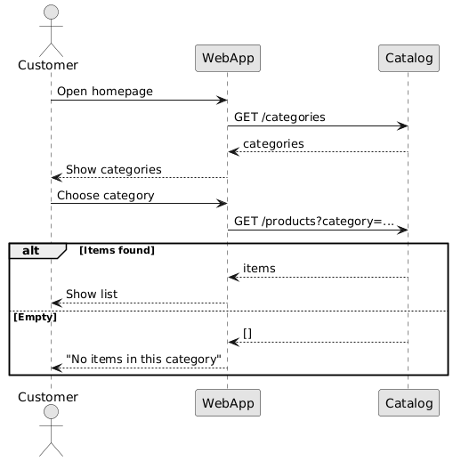
Figure 1. Browse Catalog by Category

Use Case #2: Check Local Stock Availability
- Actor: Customer
- Goal: Find out if the item is available in their location.
- Success Scenario:
  - On product page, customer enters postal code or allows location.
  - System validates input.
  - System checks inventory for that location.
  - Shows result: In stock / Low stock / Out of stock, with delivery or pickup options.
  - If available, customer adds item to cart.
- Error Scenarios:
  - Case 1: Wrong postal code >> System asks to enter again.
  - Case 2: Out of stock in that region >> System shows ‘Notify me’ or nearby region option.
  - Case 3: Inventory check fails >> System shows ‘Couldn’t check stock right now. Please try again’.
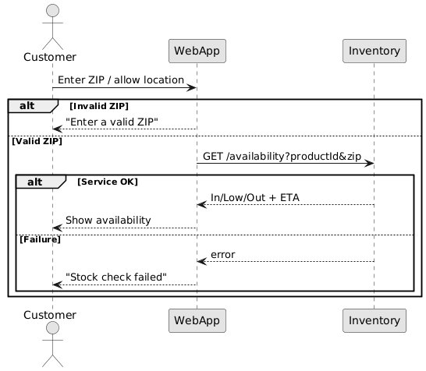
Figure 2. Check stock availability

Use Case #3: Add Item to Cart & Place Order
• Actor: Customer
• Goal: Order an available product.
• Success Scenario:
- Customer clicks Add to Cart.
- System adds product with quantity = 1.
- Customer can change quantity and clicks Checkout.
- Enters shipping details and chooses delivery/pickup option.
- Reviews order summary with condition labels, quantities, and total.
- Confirms order → System saves order and shows confirmation page with order ID.
• Error Scenarios:
- Case 1: Stock changed (if not available) >> System updates cart and shows alternatives.
- Case 2: Quantity more than stock >> System reduces to available quantity and alerts customer.
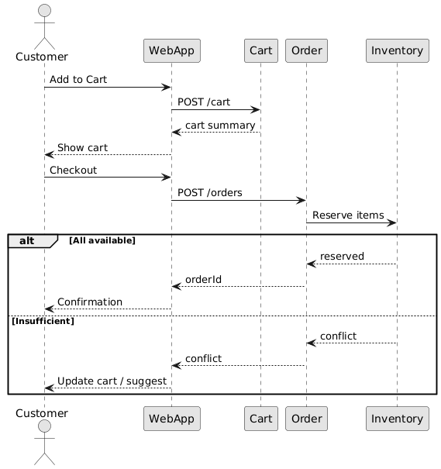
Figure 3. Add Item to Cart & Place Order

Use Case #4: Search & Filter by Condition
- Actor: Customer
- Goal: Quickly search and narrow products by category or condition.
- Success Scenario:
  - Customer enters a keyword in search like ‘Game Boy’.
  - System shows matching results.
  - Customer applies filters: Category = Gaming Consoles; Condition = Second-hand.
  - System updates and shows filtered items with counts.
  - Customer opens a product page.
- Error Scenarios:
  - Case 1: No results found >> System shows ‘No matches, clear filters to try again.’
  - Case 2: Both conditions unchecked >> System asks to select at least one.
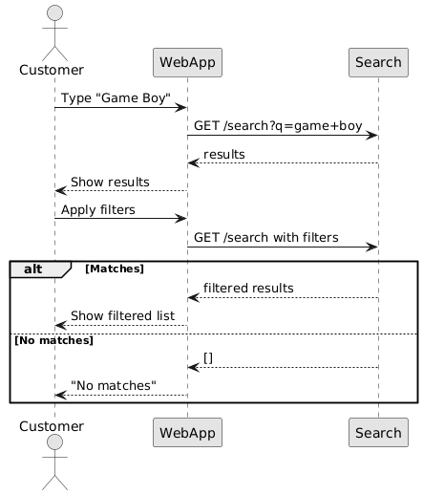
Figure 4. Search and Filter by condition

Use Case #5: Save for Later / Wishlist
- Actor: Customer
- Goal: Save an item to check later.
- Success Scenario:
  - Customer clicks Save / Wishlist on product.
  - System adds item to saved list.
  - Customer can open wishlist later and go back to product.
- Error Scenarios:
  - Case 1: Save action failed >> System shows ‘Could not save item, try again’.
  - Case 2: Item later unavailable >> System marks it as “Unavailable” in wishlist.
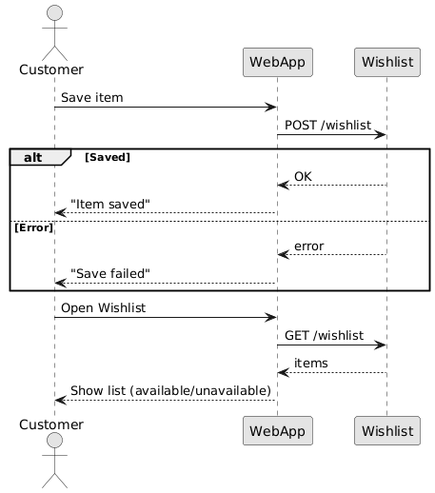
Figure 5. Save product for later
3. References
[1] P. Pocatilu, “Modeling e-commerce applications using UML,” Informatica Economica Journal, vol. 12, no. 1, pp. 71–75, 2008.
[2] A. Turban, J. Outland, D. King, J. Lee, T. Liang, and D. Turban, Electronic Commerce 2023: A Managerial and Social Networks Perspective. Cham, Switzerland: Springer, 2023.
[3] M. Hassenzahl and N. Tractinsky, “User experience – a research agenda,” Behaviour & Information Technology, vol. 25, no. 2, pp. 91–97, 2006.
[4] J. Smith, “Why retro and vintage products are booming online,” Journal of Consumer Culture, vol. 23, no. 3, pp. 456–472, 2023.
[5] Statista Research Department, “Global collectibles market size and growth forecast,” Statista, 2024.
[6] R. Hernandez, “Nostalgia in commerce: The rise of retro shopping,” Harvard Business Review, 2022.

